UPMC Pharmacy Website

*Task04*

Team 9

Team Member: Misty Yang, Josie Liu, Shuoze Wang, Jiaqi Wu, Yanlin Liang

|  |  |  |  |
| --- | --- | --- | --- |
| **05-863/08-763/46-863: Introduction to Human Computer Interaction for Technology Executives**  **Heuristic Evaluation Report**  **Dated**  **11/01/2017**   |  | | --- | | **Prepared By:**  **YOUR NAME: Team 9**  **SIGNATURE : Team9** | |  |  |  | | --- | | **Evaluation Of:**  **Name of system being evaluated (if any):** N/A  **Person who created the system being evaluated:** N/A | |

|  |  |
| --- | --- |
| Feedback & Critical Incidence | << Record your observations in the table on the following page, based on your observations and notes taken during the user test  Description of columns in the table are as follows:  *Prototype Screen/Page:*  Which screen of the user interface was being tested at the point of feedback/critical incidence/problem.  *Name of Heuristic:*  Which of the 10 heuristics is being referenced. Enter the full name of the heuristic. Here is a list: <http://www.nngroup.com/articles/ten-usability-heuristics/>  *Reason for negative feedback / breakdown:*  Explain the reasons why the interface violates or upholds this heuristic. Be sure to be clear about *where* in the screen you are referencing.  *Scope:*  Describe the scope of the feedback or the problem; include whether the scope of the issue is throughout the product or within a specific screen or screens. If the problems are specific to a page, include the appropriate page numbers.  *Severity (H/M/L) :*  Your assessment as to whether the implication of the feedback is *low*, *medium*, or *high* severity, and a justification for why you are giving it that rating.    *Way(s) to rectify and Tradeoffs (i.e., why the fix might not work):*  Suggestion for the modifications that might be made to the user interface to address the issue or issues in this row. You MUST include trade-offs to be credible. If you can’t think of some bad trade-off, say so.  *Action taken and Justification:*  DO NOT FILL IN THIS COLUMN. This will be filled in by the person who created the system being evaluated, to say what he did with respect to the recommendations you make. |

|  |  |  |  |  |  |  |  |
| --- | --- | --- | --- | --- | --- | --- | --- |
| **#** | **Prototype Screen** | **Name of Heuristic** | **Reason for negative feedback / breakdown** | **Scope** | **Severity**  (High/ Medium/ Low) and **Justification** for giving it that rating | **Way(s) to rectify and any Tradeoffs** (i.e., why the fix might not work) | **Action taken and Justification (*to by filled in later by the person who created the system being evaluated*)** |
| 1 | See Picture 1 | **Aesthetic and minimalist design** | Both of “Your account” and “login/sign up” links would lead to the same login page. Not necessary to have two. Also, it might be not reasonable to show “login/sign up” to users who are in their accounts. | Every page | Rating: Low  Rationale: Users are highly likely to ignore this issue. | If the user does not login, “Your account” is not necessary; if the user already login, only leave the “Your account” link.  Tradeoff: This may result in an inconsistency with something else, but unknown what that might be. | No change  This is not necessary and users won’t get confused. Other e-commerce website such as Amazon also does have account when users are not signed in. |
| 2 | See Picture 2 | **Consistency and standards** | Different headers in different pages. | Except the home page. | Rating: Medium  Rationale: The second header may mislead customers. | Just change the rest headers.  Tradeoff: This may result in an inconsistency with something else, but unknown what that might be. | Headers are changed to be all the same |
| 3 | See Picture 3 | **Flexibility and efficiency of use** | Plus and minus buttons in quantity field are too small and not obvious enough. This initially leads me think I need to input the quantity by myself. | Product page and cart page. | Rating: Medium  Rationale: Customers may fail to see the plus and minus buttons, especially for those in old age. | Adding obvious buttons outside the quantity box would be better.  Tradeoff: This may result in an inconsistency with something else, but unknown what that might be. | No change  Users can input the value by themselves as well and the plus and minus buttons are very not very small. |
| 4 | See Picture 4 | **Flexibility and efficiency of use** | In the sign in page, there is a checkbox called “sign in”. I get confused about what the meaning of that. I think “sign in” should be the submit button. | Sign up page | Rating: High  Rationale:  Very confused to customers. | Change the “submit” button into “sign up”, and delete the checkbox.  Tradeoff: The “sign up” checkout may have other meanings, but unknown what that might be. | Change checkbox content to “keep me signed in”. Also add a “already” have an account option. |
| 5 | See Picture 5 | **Confusion** | The “enter coupon code” button is a bit strange. In my view, enter coupon code looks more similar to a text field, not a button | Cart page | Rating: Low  Rationale: Not a big problem to function | Change the “enter coupon code” button into something else, such as “apply code”.  Tradeoff: This may result in an inconsistency with something else, but unknown what that might be. | The button has been changed to  “Apply Code” |
| 6 | See Picture 6 | **Page not found** | After clicking the “enter coupon code” button, it leads to a page not found. | Cart page | Rate: Low  Rationale: Not a big problem | After clicking the button, it would be better to refresh this page, not lead to a page not found.  Tradeoff: This may result in an inconsistency with something else, but unknown what that might be. | After clicking the button, it refreshes this page |
| 7 | See Picture 7 | **Flexibility and efficiency of use** | If customers want to change the quantity if one product, they need to scroll down to the bottom to click “update”. It would be inconvenient if the buying list is long. | Cart page | Rate: Medium  Rationale: It would be inconvenient if the buying list is long. | Let the order summary automatically change after customers modifying the quantity.  Tradeoff: This may result in an inconsistency with something else, but unknown what that might be. | Delete “update cart” and users can change the quantity and then continue checking out. |
| 8 | See Picture 8 | **Match between system and the real world** | Some customers may not live in an apartment, so they do not have APT/suite number. It is not reasonable to set this field as a compulsory one. | Checkout page | Rate: High  Rationale: May lead some customers living in individual houses get confused and fail to enter their address. | Just make it as an optional field.  Tradeoff: This may result in an inconsistency with something else, but unknown what that might be. | It has been changed to an optional field. |
| 9 | See Picture 9 | **Match between system and the real world** | It is a bit strange to let customers enter their whole billing address into one text field. | Checkout Page | Rate: High  Rationale: It is very confused to customers. | You would better to split the “billing address” into different lines, such as “address line1”, “address line2”, “phone number”, etc.  Tradeoff: This may result in an inconsistency with something else, but unknown what that might be. | Add more fields to billing address form. |
| 10 | See Picture 10 | **Recognition rather than recall** | The order confirm page only shows the order detail, billing address and payment method, but does not show the shipping address. | Checkout page | Rate: Medium  Rationale: Customers need to check whether the shipping address is correct before placing orders | Just add a section of shipping address.  Tradeoff: This may result in an inconsistency with something else, but unknown what that might be. | Add a section of shipping address. |
| 11 | See Picture 11 | **Consistency and standards** | **Inconsistent Header:** Language and currency selection is only visible on home page | Every page | Rating: Medium – critical problem.  Rationale: users might not remember to change currency until they jump to product detail page | Rectification: make language and currency selection available on every page.  Tradeoffs: Cannot think of any tradeoffs | Make language and currency selection available on every page. |
| 12 | See Picture 12 | **Flexibility and efficiency of use** | **Missing page selection button:** There is no button for jumping to other page at the top of search result page / product page | Search result page / product page | Low – minor problem.  Rationale: sometimes users scroll down and then up to check the products again, and it would be better to have the button on top of product list | Rectification: add page selection button on top of product list  Tradeoffs: might affect aesthetic design | Add “go to page” on top of 3 pages: 1 search and 2 product pages |
| 13 | See Picture 13 | **Consistency and standards** | **Misleading wording**: it is leading to great confusion to have “new” items under “On Sale” panel | Index page | High – fatal problem.  Rationale: “Sale” tag is expected for products under “On Sale” panel instead of “New”. Users are not sure whether this is new to sale or new arrival | Rectification: rename the tag to indicate specific information e.g. “New Arrival” / “New to Sale”  Tradeoffs: longer words could affect aesthetic design | Change new icon to sale. |
| 14 | See Picture 14 | **Consistency and standards** | **Inconsistent layout:** products under “Best Sellers” and “On Sale” have different layouts ---- one only has “More details” button and other has more detailed information | Index Page | High – fatal problem.  Rationale: it is better to have consistent layout. Probably there are specific reasons behind the design but I would prefer the design under “On Sale” and adopt it in “Best Sellers” because those are more likely the products users might be interested | Rectification: Adopt the same design for every product listed on index page  Tradeoffs: might be useless to put details on home page since users always review product details before purchasing | Change best sellers layout to be the same as on sale |
| 15 | See Picture 15 | **Aesthetic and minimalist design** | **Unaligned borders:** the borders are unaligned | Index page | Low – cosmetic problem.  Rationale: users especially users with OCD may find it hard to overlook | Rectification: make border consistent or remove borders  Tradeoffs: Cannot think of any | Borders are changed all aligned. |
| 16 | See Picture 16 | **Match between system and the real world** | **Confusing checkbox:** No idea what the “Sign Up” checkbox is for | Register page | High – fatal problem.  Rationale: users could be very confused what the “sign up” checkbox is for, and whether or not they should check it when creating an account | Rectification: Explain more for the check box or provide instructions for users when to / not to check the sign up checkbox  Tradeoffs: could be a default opt-in design for communication / advertisement emails, and might have more people opting out with more explanations | Change checkbox content to “keep me signed in”. Also add a “already” have an account option. |
| 17 | See Picture 17 | **Recognition rather than recall** | **No shopping cart information when mouse hovers over:** when mouse hovers over the shopping cart icon, no information shows the products inside current shopping cart | Every page | High – fatal problem.  Rationale: without shopping cart information, users need to enter the shopping cart page each time when they need to review the cart, and go back to the previous page to continue shopping. | Rectification: have pop-up window shows the items and brief information under the current shopping cart when mouse hovers / clicks on the shopping cart icon  Tradeoffs: cannot think of any | Now there is a shopping cart pop-up for every page |
| 18 | See Picture 18 | **Error prevention** | **Must click “Update Cart” to update shopping cart:** shopping cart information will not be saved until users click on “Update cart” | Shopping cart / checkout page | High – fatal problem.  Rationale: better to constantly update shopping cart when users take any actions because it is always easy to forget to “update cart” or some users do not notice that they need to “update cart” to save the updates | Rectification: delete “update cart” button and make it real-time responsive to users’ actions  Tradeoffs: error / condition checking logic needs to be added upon every action button instead of just one “update cart” button | Delete “update cart” and users can change the quantity and then continue checking out. |
| 19 | See Picture 19 | **Flexibility and efficiency of use** | **Missing “Add to cart” button**: there are no “Add to cart” button / product brief information such as price / review snapshots like those on the index page | Product result / search result page | High – fatal problem.  It is highly likely that users have in mind what to purchase and will add the item to cart once they found it in search result | Rectification: Apply the design of products under “On Sale” panel at index page to the design under search result / product result  Tradeoffs: could lower visibility of recommended products which are listed on product detail page | Add “add to cart” button for each product on search and product pages. |
| 20 | See Picture 20 | **Visibility of system status** | **Missing sub-header for recommended products:** no description / header explained for what the scrolling products are / their usage | Product detail page | High – fatal problem.  Users have no clue what is going on with the scrolling products under “Direction” | Rectification: add the sub-header like “Recommendation”  Tradeoffs: cannot think of any | Add the header ”you might also like” |
| 21 | See Picture 21 | **Visibility of System Status.** | Add to Cart button doesn’t show what is happening. | Every page that contains add to cart button. | Rating: High. Rationale: The user will have trouble identifying what happened after clicking the add to cart button. | You can add a prompt to show that the item has been added in the cart. | Add a pop up window to show the product has been added. |
| 22 | See Picture 22 | **Consistency and Standard** | The product detail page contains the quantity option which let you select 0 as quantity. | Every page that contains the quantity option. | Rating: High.  Rationale: It is misleading that user can select 0 quantity. | You can set the minimum limit to one in combo-box(the drop down box). | The minimum limit of quantity is set to 1 |
| 23 | See Picture 23 | **Recognition rather than recall.** | The search box doesn’t contain any suggestions. | Every page that contains search box. | Rating: Medium.  Rationale: The user may find it annoying remembering things. | You can add suggestions to the text field. | Already have search suggestion in the box. This is a wrong information. |
| 24 | See Picture 24 | ***Help users recognize, diagnose, and recover from errors*** | No 404-error message page. | Every Page. | Rating: High.  Rationale: If user clicks on any of the link which is not directing to something the users gets confused with the texts and links. | Just give href to every not defined link you have given in every page to 404 page. | A 404 page has been added. |
| 25 | See Picture 25 | **Help and Documentation.** | *in login, sigup page, checkout is not defined. | Login, SignUpand Checkout | Rating: High.  Rationale: The * is misleading in every page. Identification is must. | Just provide a sign saying what it actually means. | Add * definition on all mentioned pages. |
| 26 | See Picture 26 | **Aesthetic and Minimalist Design.** | Many spellings mistake. | Every page. | Rating: High.  Rationale: User should get a proper site with proper names and words and currency. | Just correct it and use right words. | Correct all the spelling mistakes. |
| 27 | See Picture 27 | **Consistency and Standard** | Password field is not used, instead it is a text field. | Login, Signup page | Rating: High.  Rationale: User’s password is a confidential element. It should be a password field. | Just use password field instead of text field. | Change to password on signin, signup, and checkout 3 page. |
| 28 | See Picture 28 | **Consistency and Standard** | Cart in cart Page and checkout page is different. Also, the text fields shape is not same in the checkout pages. | Cart and  Checkout Page. | Rating: Low.  Rationale: It won’t affect user but aesthetically and consistency wise it is not looking goof. | Just use same css property through out. For Text fields and the cart also. | The two items are same now. |
| 29 | See Picture 29 | **Aesthetic and minimalist design** | Inconsistent placement of down arrow button in each presented category inside the left navigation bar. | All pages with navigation bar on the left | Rating: Low – Minor, cosmetic problem. Rationale: Unlikely that users will have trouble with finding or recognizing the button. | Align all the down arrow buttons to the left boundary of the left navigation bar. | The arrows have been changed to be next to the label. |
| 30 | See Picture 30 | **Consistency** | The breadcrumb in the homepage has only two pages instead of three pages. | Homepage | Rating: Low – Minor, cosmetic problem. Rationale: Unlikely the user will experience any major break down | Add one more page to the breadcrumb on the homepage. | It has been changed to 2 pictures |
| 31 | See Picture 31 | **Match between system and the real world** | Brief information is confusing and incomplete for each products shown in search results and the recommendation slider at the end of the page. | Search Results Page, Product Detail Page, Product Category page. | Rating: Medium, Incomplete information will confuse the user Rationale: The user will find it difficult to select different products | Provide more concise and complete information to the user for each product. | No change. This is not UI-related. We have product description we use in our user tests. |
| 32 | See Picture 32 | **Consistency** | Radio Buttons are not aligned with option information provide on the left | Check Out page | Rating: Low – Minor, cosmetic problem. Rationale: Unlikely that users will have trouble using the checkout form | Align all the radio buttons with the information provided | All the radio buttons have been aligned. |
| 33 | See Picture 33 | **Match between the system and the real world** | The meaning of sign up check box is confusing in the register page, since its sole purpose is to register new user. | Register page | Rating: Medium, Rationale: confusing information presented at the register page might make the user unwilling to register | Remove the signup checkbox or add other information illustrating the purpose of this checkbox. | The signup box has been removed |
| 34 | See Picture 34 | **Visibility of the system’s status** | The links on the one of the product is not clickable | Home Page | Rating: Minor, Rationale, although this is a prototype, all the links on the web page should be at least clickable. | Make the links clickable or even redirect to another page. | The links are changed to clickable |
| 35 | See Picture 35 | **Flexibility and efficiency of use** | When the user goes back to the previous form, the web page won’t allow him to go forward to the form which he had already filled | Check Out Page | Rating: Medium, Rationale: the user might have to refill all the information after going back, which is really inconvenient. | Adjust the functionality of directing the user to go back and forward during the checkout process. | No change  User can click continue to the next step to the next page |
| 36 | See Picture 36 | **Consistency and standards** | In the top bar, the language and currency selection is actually different for home page and user account page. | Home Page and User account page. | Rating: Medium. Rationale: the user might experience difficulty in switching the language in different pages | In the user account page, adjust the language selection and currency selection in the top bar to be the same with the one in home page. | Every language selection and currency selection is changed to the same |
| 37 | See Picture 37 | **Consistency and standards** | The Free Shipping limit should be consistent on every page. On Home page, the limit is $50. However, on Search Page, the limit becomes $500. | Header | Medium. It may cause confusion for novice user. Also may lead to some credibility loss of website as whole. | Make limit on every page consistent, i.e. $50. | Every page banner is changed consistent |
| 38 | See Picture 38 | **Visibility of system status** | The “Your Account” button displays at every stage. User might be confused whether they are login or not. If user is not login, then “Your Account” should not be here. | Header | Low. People will found this button confusing, but after click it they will understand whether they are login or not. | Hide the “Your  Account” button while user not login. | No Change  People won’t get confused |
| 39 | See Picture 39 | **Match between system and the real world** | Every product on website have a rating, but there is no place for user to view specific review on product. It makes user confuse about the source of the rating. | Detail Page | High. The rating is critical reference for user to make purchase decisions. If the rating is coming from nowhere, the credibility of rating will be damaged. | 1. Add review related design on detail page. 2. Claim that the rating is giving by UPMC or another trusted source, i.e. Amazon. | The review has been added to detail page.  The rating of trusted source has been claimed. |
| 40 | See Picture 40 | **Recognition rather than recall** | The product item card on Products page have few information. Maybe the price should be on it. The lack of information will make user very hard to compare products. | Category Page or Products Page | High. The display of bulk of products without enough information will make them indistinguishable. It’s not favor the sale of product or product searching. | Add more information to each item card, i.e. price, rating, purchases number, discount, credibility badge. | Add price, rating, and “add to cart” button for each product. |
| 41 | See Picture 41 | **Flexibility and efficiency of use** | The Products page should have a more powerful filter to filter through all the products on criteria like brand, strength, life stage and so on. If the search result reaches 100 items, then it will be quite a trouble for user to locate the correct one out from it. | Category Page or Products Page | Medium. This trouble will only occur when the search result is huge. It can be covered by advanced | Add a more specific filter on the top of Products page. | Add filter to 2 product pages. |
| 42 | See Picture 42 | **User control and freedom** | There is no remove button on Cart page. I guess if user want to remove an item, he or she should first change the quantity to 0 then click update. This procedure can be improved. | Cart Page | Medium. If user accidentally choose some unwanted product, they will be quite annoyed about the un-removable item. | Add remove button on every item on Cart page. | Remove buttons are added in the cart page. |
| 43 | See Picture 43 | **Match between system and the real world** | There is no enough room for user to fill in the billing address blank. Usually the billing address will split into 2 street address fields, city, state, country fields and zip code field. | Payment page | High. It could cause breach between website data and payment API. | Add more fields to payment page. | More fields are added for payment page. |
| 44 | See Picture 44 | **Flexibility and efficiency of use** | If letting user to choose shipping method, it will be nice to calculate the estimate delivery date. If do so, user will may be encouraged to select more expensive shipping method, and have a clearer expectation about shipping. | Delivery Method Page | Low. User can calculate it by themselves. | Add estimate delivery date. | Estimate delivery date is added on confirmation page. |
| 45 | See Picture 45 | **Help and documentation** | The “SIGN UP” checkbox is confusing. I cannot imagine what it can do. README declares that this “checkbox is misleading”. Maybe it should be removed. | Sign Up Page | Low. Seems people click it or not doesn’t affect the result of sign up procedure. | Remove the “SIGN UP” checkbox. | Remove “Sign Up” check box. |
| 46 | See Picture 46 | **User control and freedom** | For senior who has few web experience and doesn’t understand the concept of “online shopping cart”, they may be confused and can’t go through the purchase procedure fluently. | Detail Page | Low. Because there is only one button on the Detail page, people can somehow proceed by guess and still finish the purchase procedure. | Add another button such as “Buy Now”, “Purchase”. | A checkout button has been added in the single product pages. |

Picture 1:



Picture 2:





Picture 3:



Picture 4:

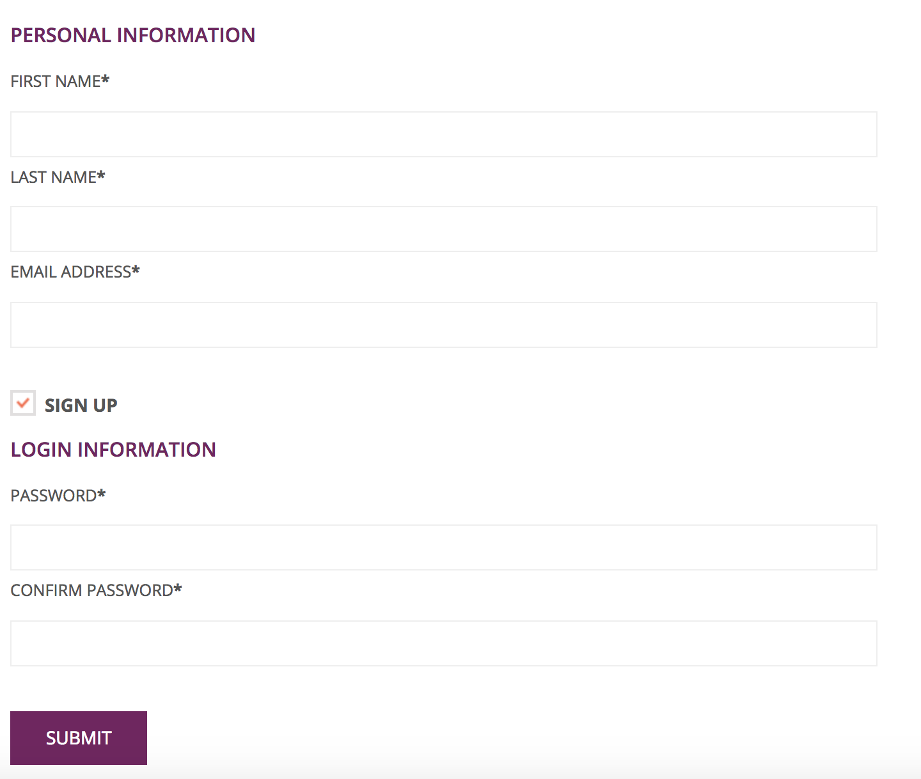

Picture 5:

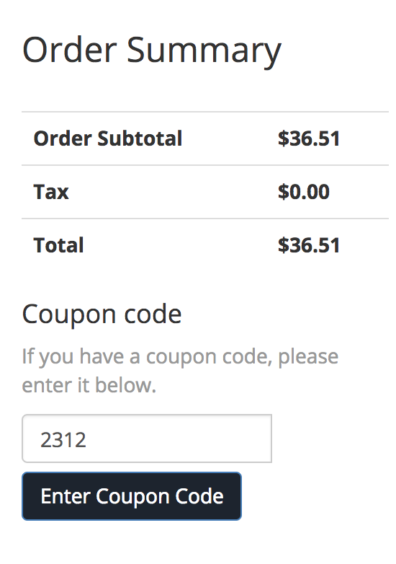

Picture 6:



Picture 7:

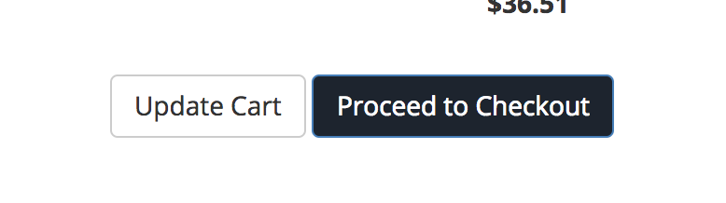

Picture 8:

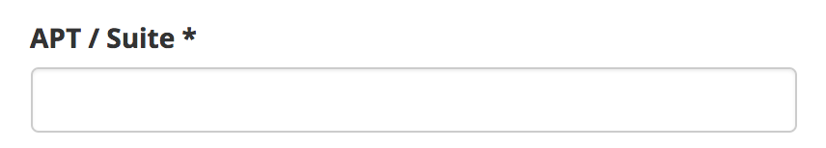

Picture 9:

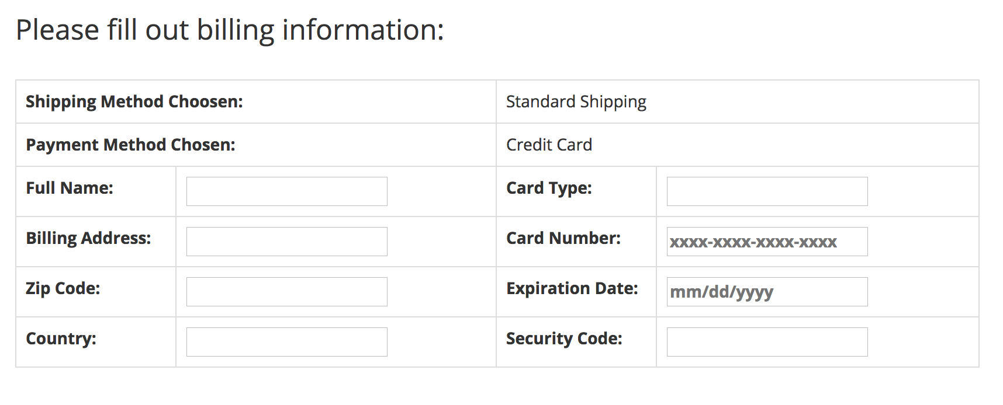

Picture 10:

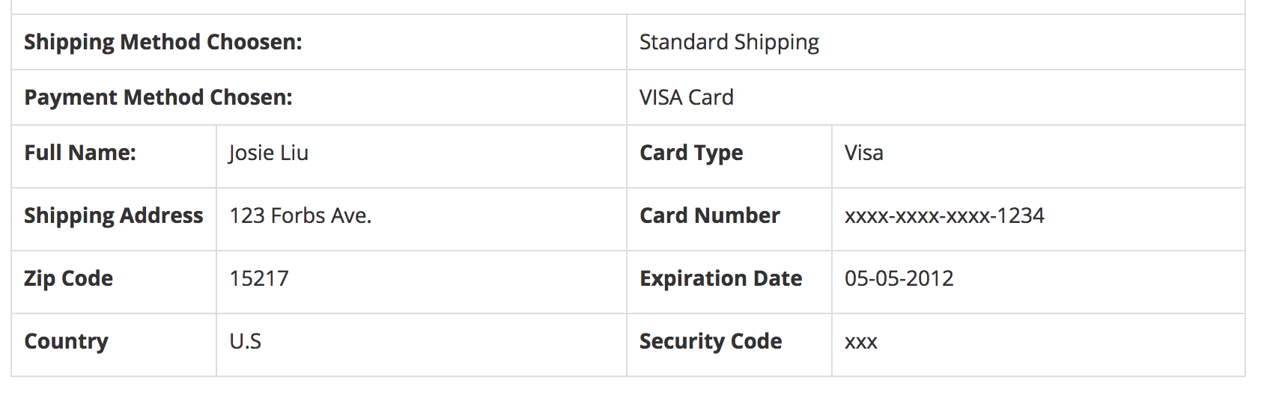

Picture 11:

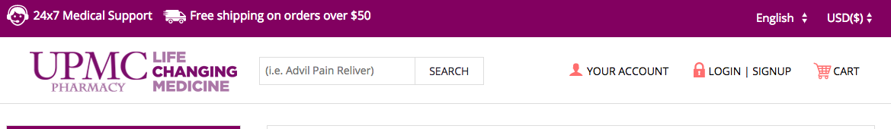

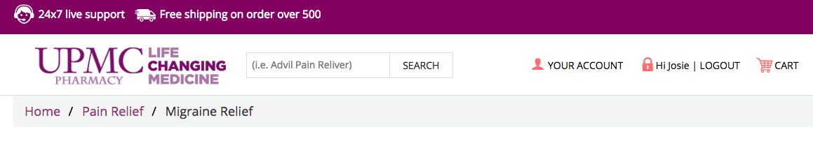

Picture 12:

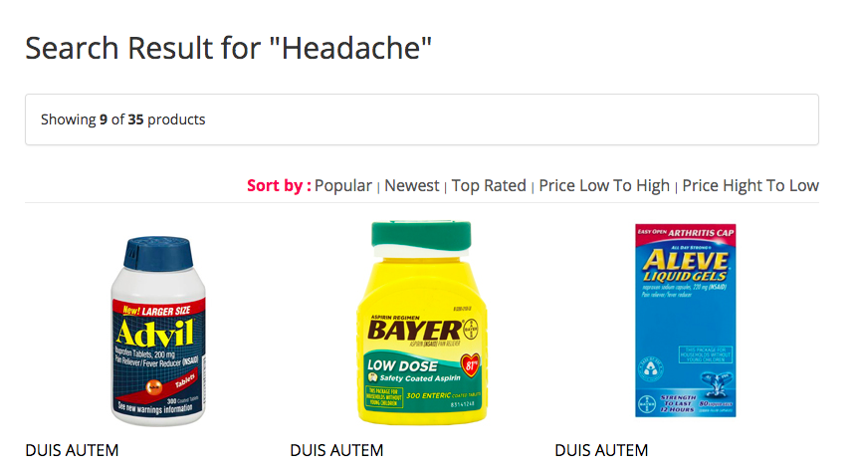

Picture 13:

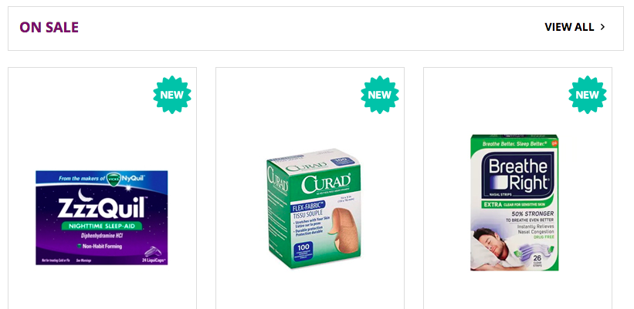

Picture 14:

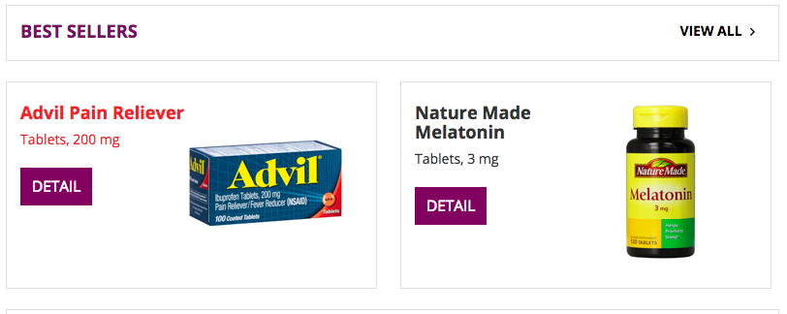

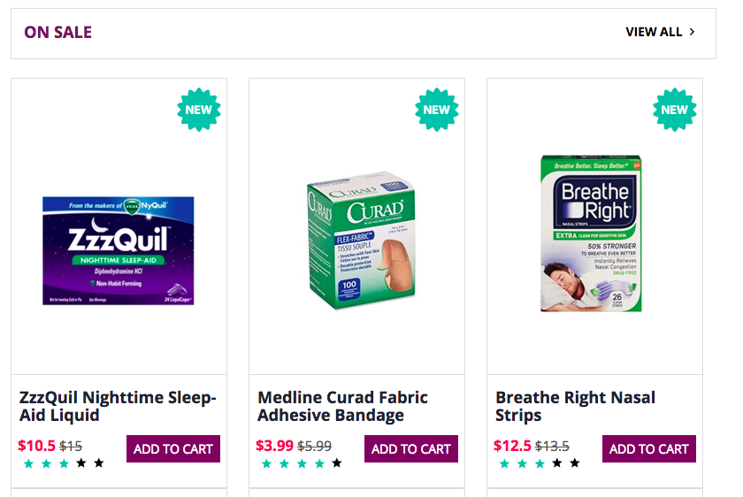

Picture 15:

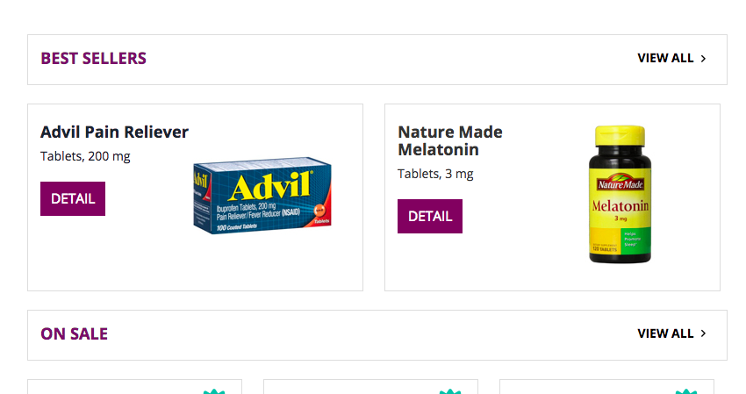

Picture 16:



Picture 17:



Picture 18:

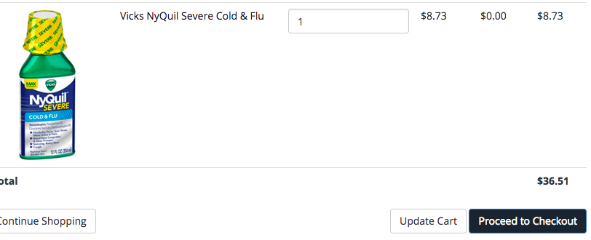

Picture 19:

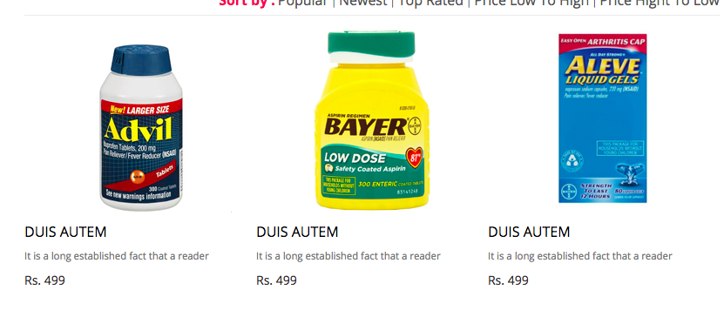

Picture 20:

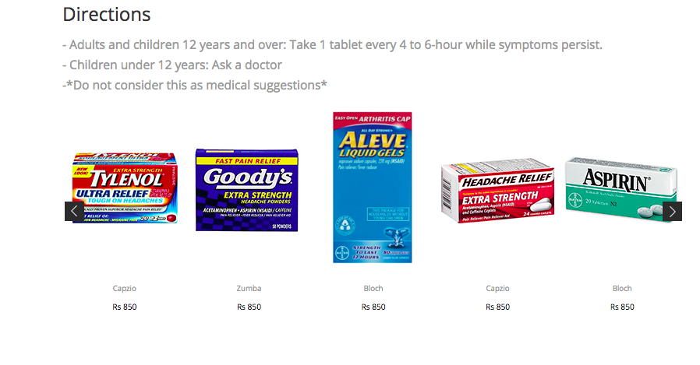

Picture 21:

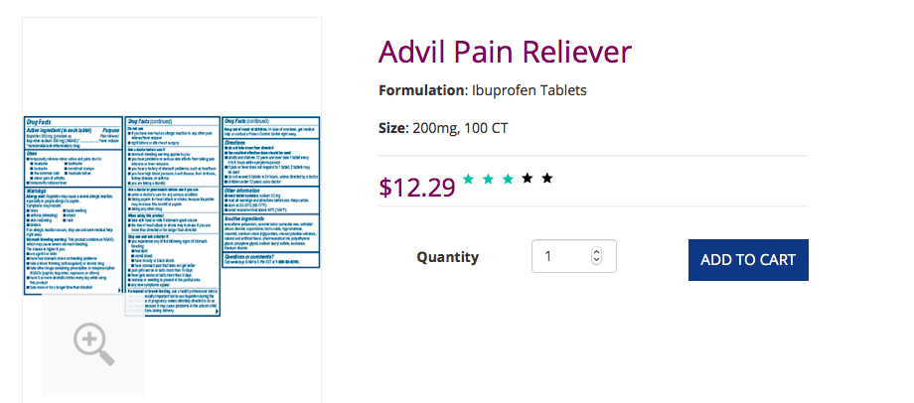

Picture 22:

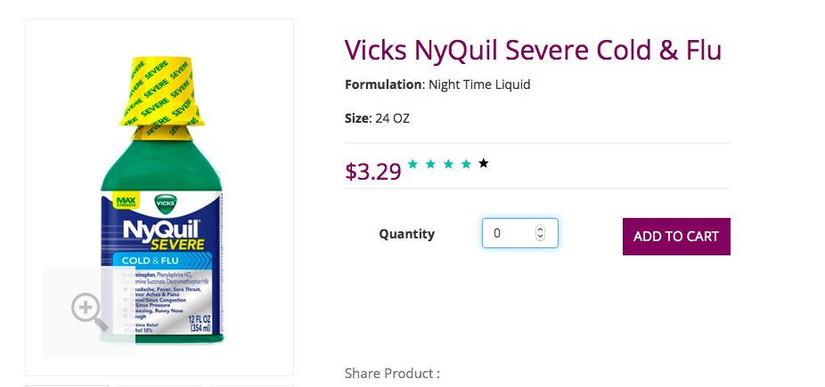

Picture 23:



Picture 24:



Picture 25:

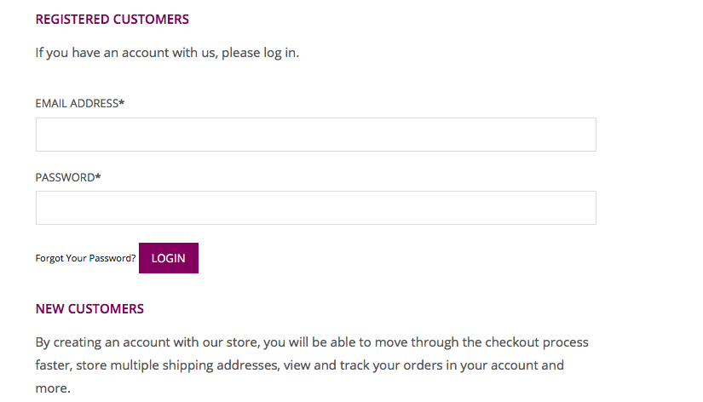

Picture 26:



*First and Purchase.

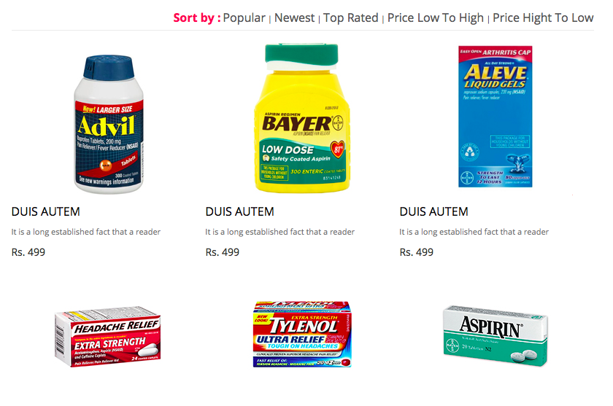

*Use correct name and currency. This is Indian Currency (Rs. : Rupees).

Picture 27:

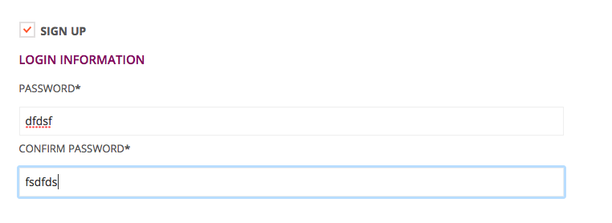

Picture 28:

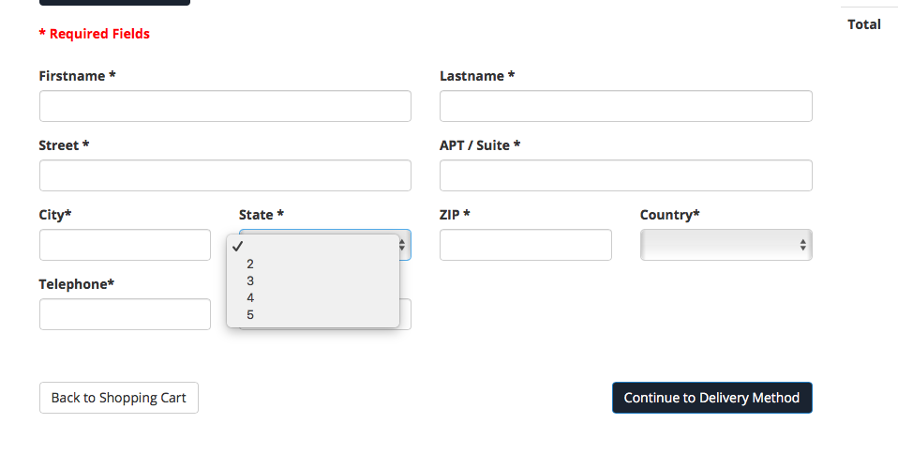

*State cannot be a number.

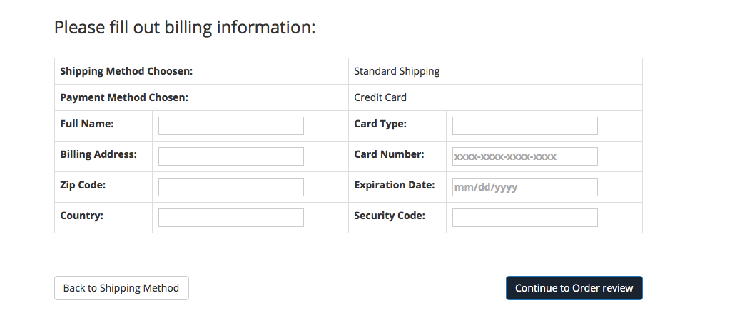

*Mark Mandatory for the above fields.

*Billing TextFields are different from the Customer details page.

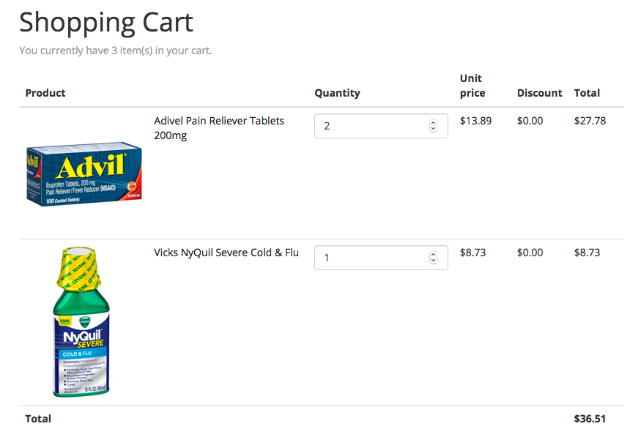 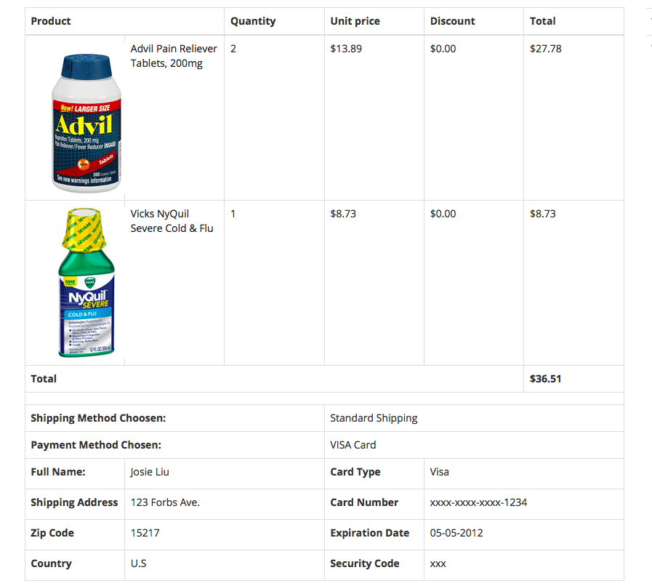

*The cart is not showing the same images and look is not even the same.

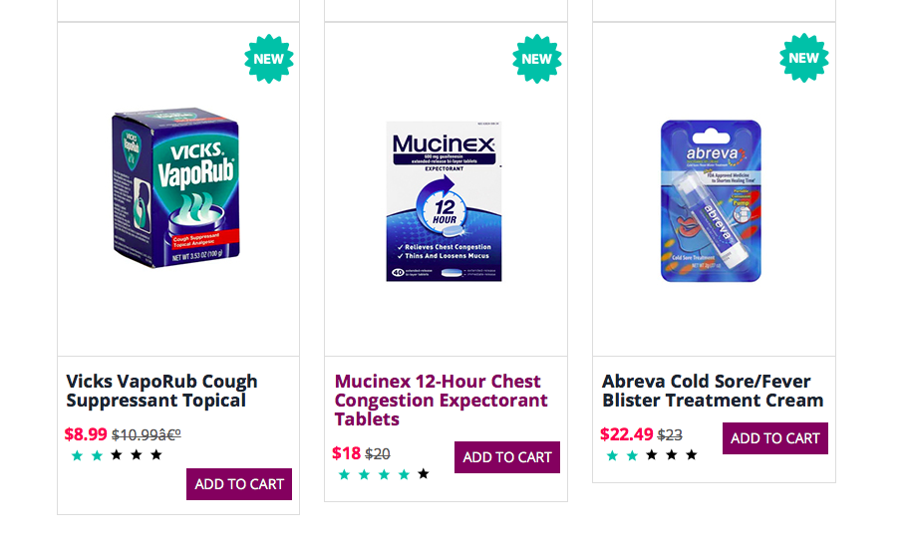

*Alignment of the above image is not proper.

Picture 29:

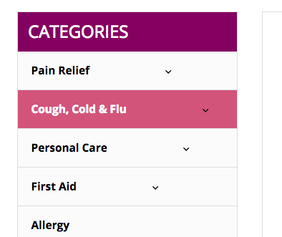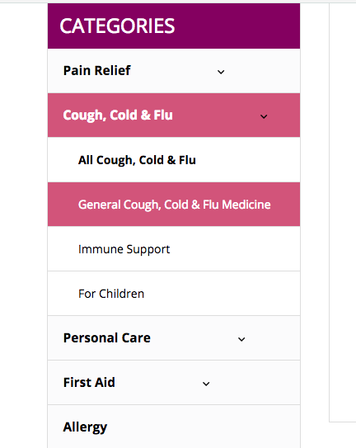

Picture 30:



Picture 31:

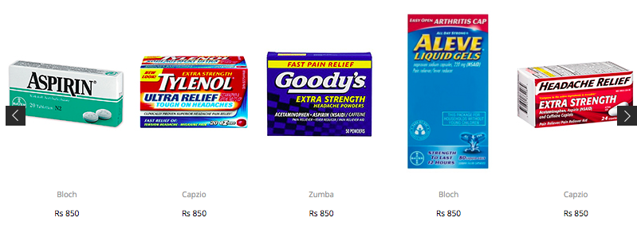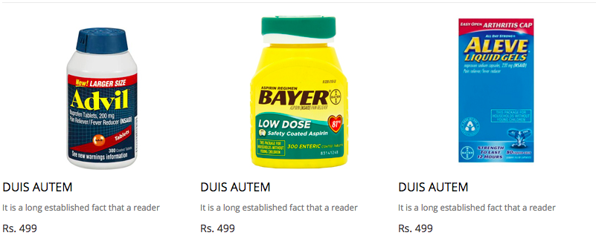

Picture 32:

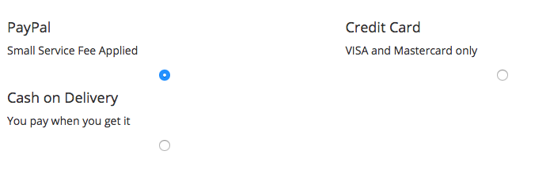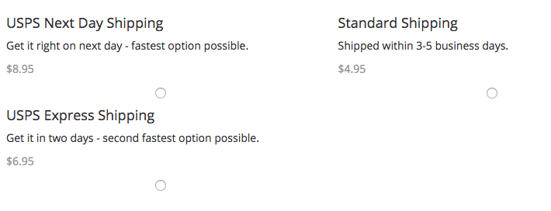

Picture 33:

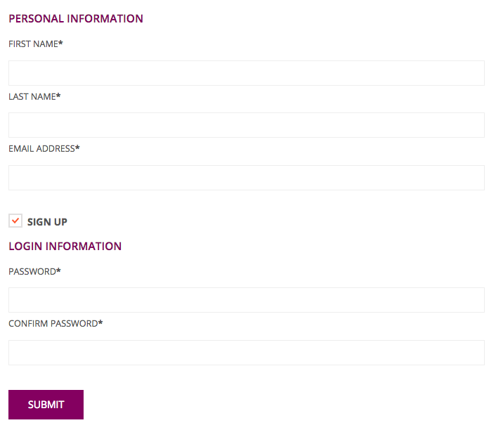

Picture 34:

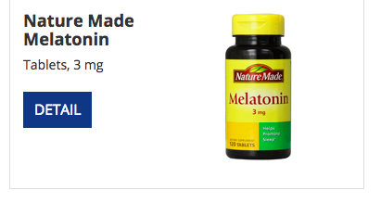

Picture 35:

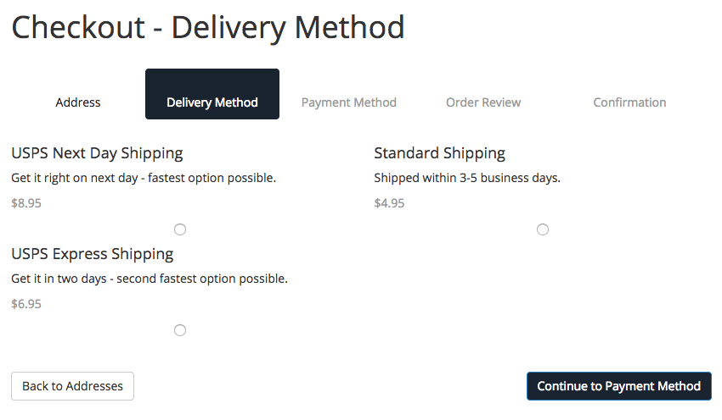

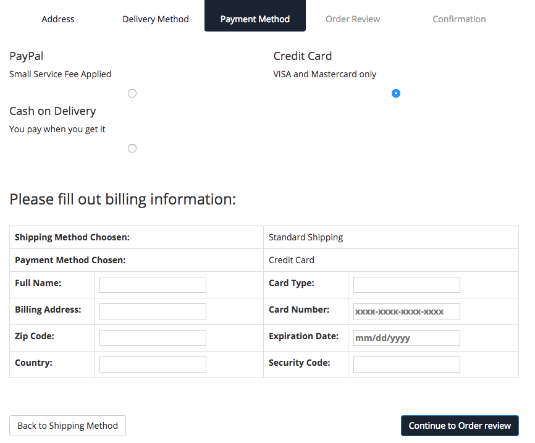

Picture 36:

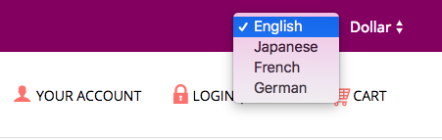



Picture 37:



Picture 38:



Picture 39:

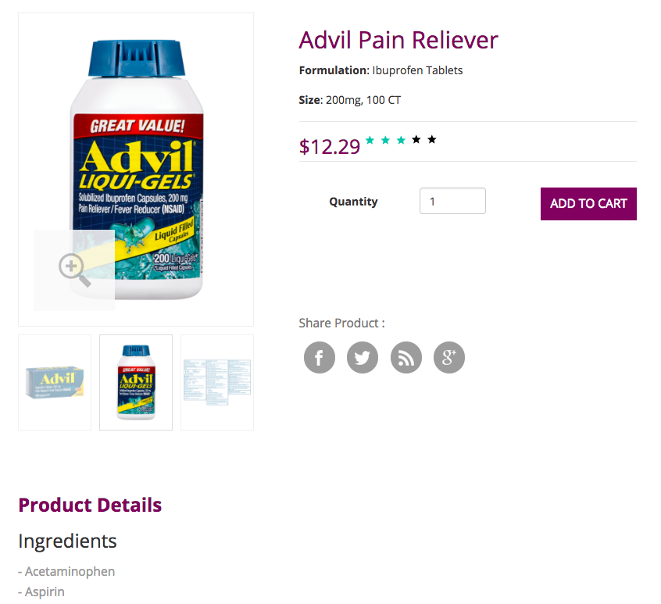

Picture 40:

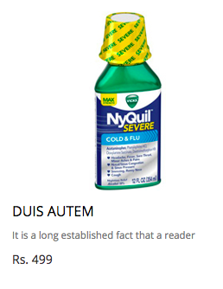

Picture 41:

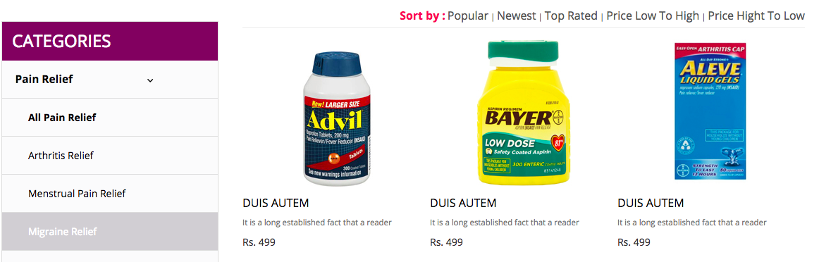

Picture 42:

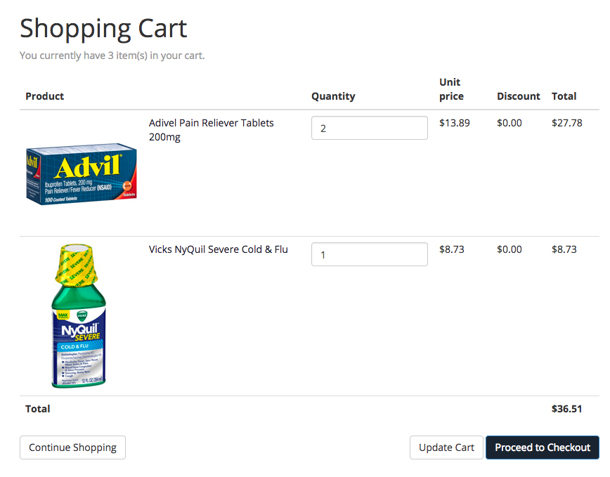

Picture 43:

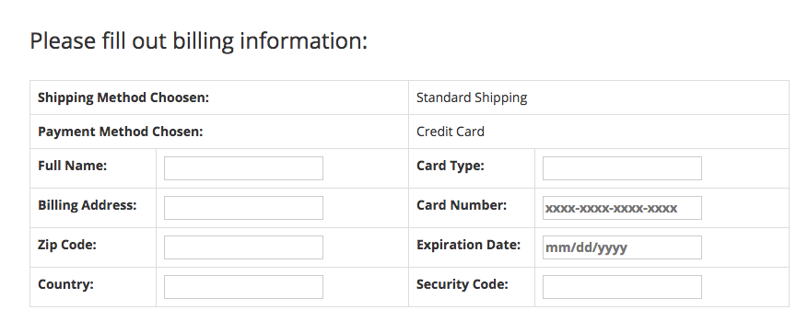

Picture 44:

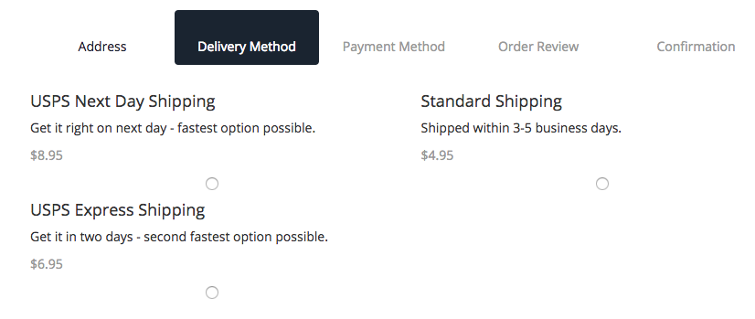

Picture 45:  
  
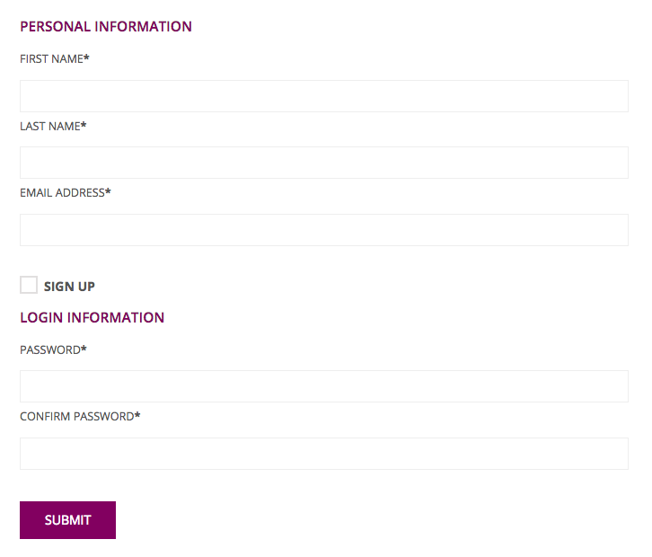

Picture 46:  
  
